Design The Tagging System

Manage the Tags
Search the Most Recent tags

Requirements :
We Have to create a System design for Tagging System
where we have to manage the tag and
can add these tags with Post or Item.
Also we should figure out how we can search the most popular tags in last 7 days

Solutions:
Based on these requirement Let me divide this problem in two phase.
1) Tag Management System
2) Found Most Popular Tags in K time

Functional Requirement :
- Manage Tag : Create/update/delete Tags
- Tag to a Post : tagPost/removeTagFromPost
- Search Most recent tags used
- Do you want the bulk upload of tags/post tags?
- Do you want the auditing of tags ?

Non-Functional Requirement :
- Scalable System
- Fault tolerance
- Performance very frequent
- Accurate as much as possible
- Availability

Metric Calculation :

- How Many request comes to create/update/tags the tags ?
- How many total tags can be in DB?
- How many post tag request will comes in a day or hour or minutes
- What will be the max value for “K” can be. Because we have to decide which DataStructure or design can be used while performing the System design for Most Recent/popular tags

1) Tag Management System

As Tags are most popular stuff which we can use in searching the item/post/document etc.

Database Model :

We will use MySQL for Managing the Tags.

tag : {tagId, tagName, status, category, createdBy, updatedBy, createdTime, updatedTime}
Primary key : tagId
Indexing : tagId, tagName
uniqueKey : tagName

post : {postId, postName, status, category, createdBy, updatedBy, createdTime, updatedTime}
Primary key : postId
indexing : postId
uniqueKey : postName

post_tag_mapping : {id, tagId, postId, status, createdBy, updatedBy, createdTime, updatedTime}
Primary key : id
indexing : postId, tagId
uniqueKey : postId, tagId

//Maintaining the logs
audit_tag -> auditId, tagId, oldValue, newValue, udatedBy, updatedTime;
audit_post_tag_mapping -> auditId, post_tag_mappingId, oldValue, newValue, updatedBy, updatedTime;

Api Design :

----------------------------
Manage the Tag Master Data :
----------------------------
1. find tag by TagId
Response<Tag> findTag(int tagId);

2. All the tags ae unique So for Inserting a new Tag
Response<Integer> insertTag(tagName);

3. update a Tag : Question : Do we need to delete or create a new one. If yes, in this case all the old post tag mapping will be invalid because the new tag will be created. So its better to change the tag name for a tagId
Response<Boolean> updateTag(int tagId, String newTagName);

4. delete a tag : Question : When we are deleting the tag So we need to delele all its entry (soft delete) in tag_post_mapping table ?
Response<Boolean> deleteTag(int tagId);

5. Search tags by a keyword
Response<List<Tag>> searchTags(String tagPrefix);

// Optional API's
1. Bulk Tag Insert via Upload
2. Bulk Tag delete via upload
3. Bulk Tag rename

----------------------------
Manage the Tag Post Mapping :
----------------------------
6. Apply tag on a post
Response<Boolean> tagPost(Integer tagId, Integer postId);

or // If Application provide suport for multiple tag to be added with in one go

Response<Boolean> tagPost(List<Integer> tagId, Integer postId);

7. remove a tag from post
Response<Boolean> removeTagPost(int tagId, int postId);

8. Get All tags for a Post
Response<List<Tag>> getPostTages(int postId);

9. Get All Post for a tag
Response<List<Post>> getAllPostsByTag(int tagId);

// Optional API's
1. Bulk Tagging to Post

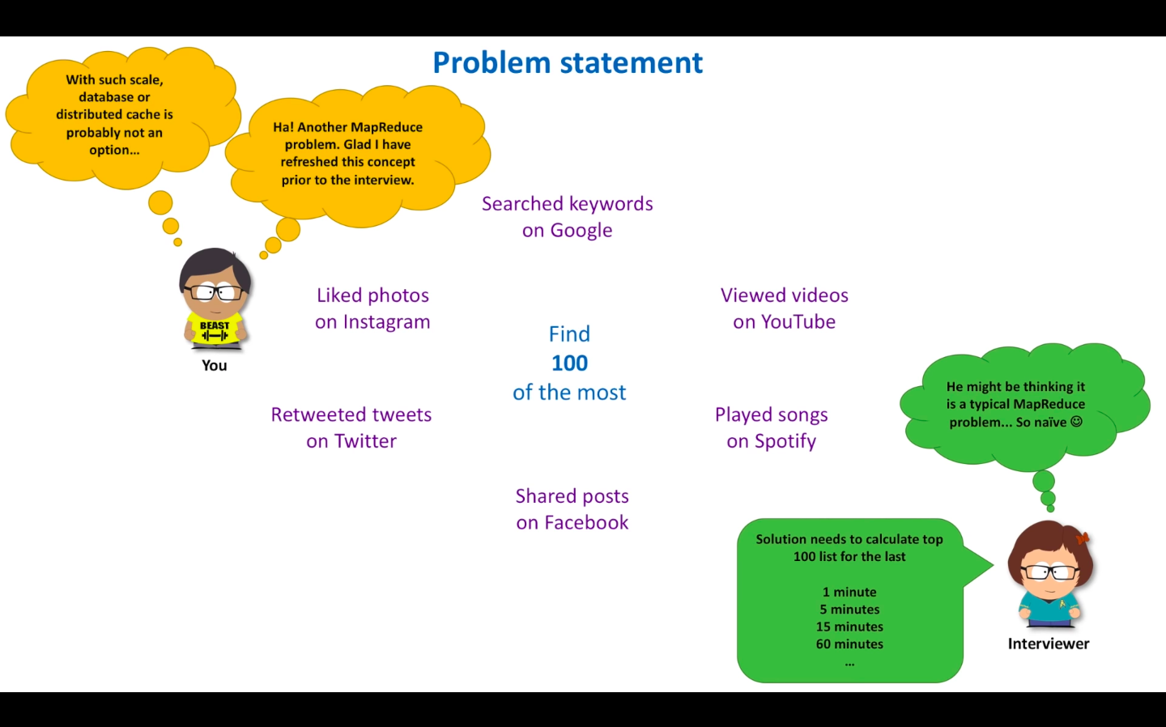

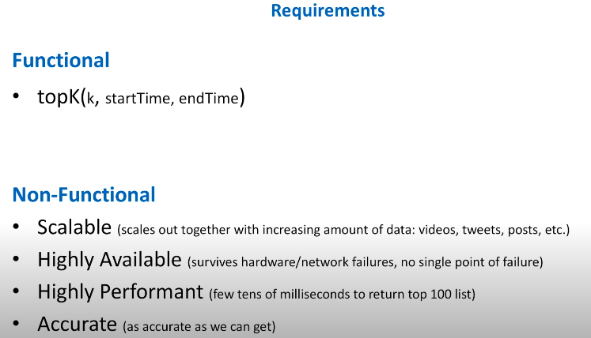

As per the requirement Actor/Client want K result. That mean if we want to return the result in tens of milliseconds, Then we have to pre calculate the results. And for request we can return the result.

Start Discussing :

Solution 1 :. Sampling : We can use sampling, But it will not generate the result Because it generate the result based on the sample we picked. So no need to use this.

Solution 2 :HashTable/HashMap Single Host: If the Size is too big So hash Table will create the Issue because of Very Big size and then we have to perform the sorting based on its frequency count. So it will require O(nlog(n)) time complexity. So we can add Heap along with HashMap/HashTable With heap it will give O(nlog(k)) complexity.

As the solution is simple to implement But This solution will not work with large traffic and also its a single system So if its down complete system will down. So it will be a bottleneck for large traffic of data.

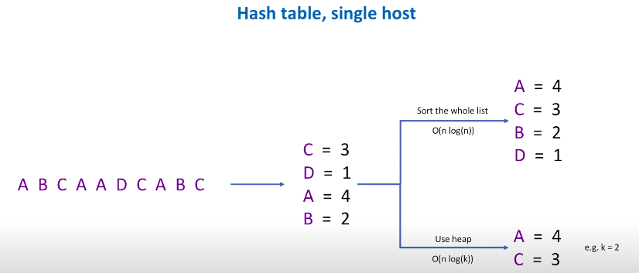

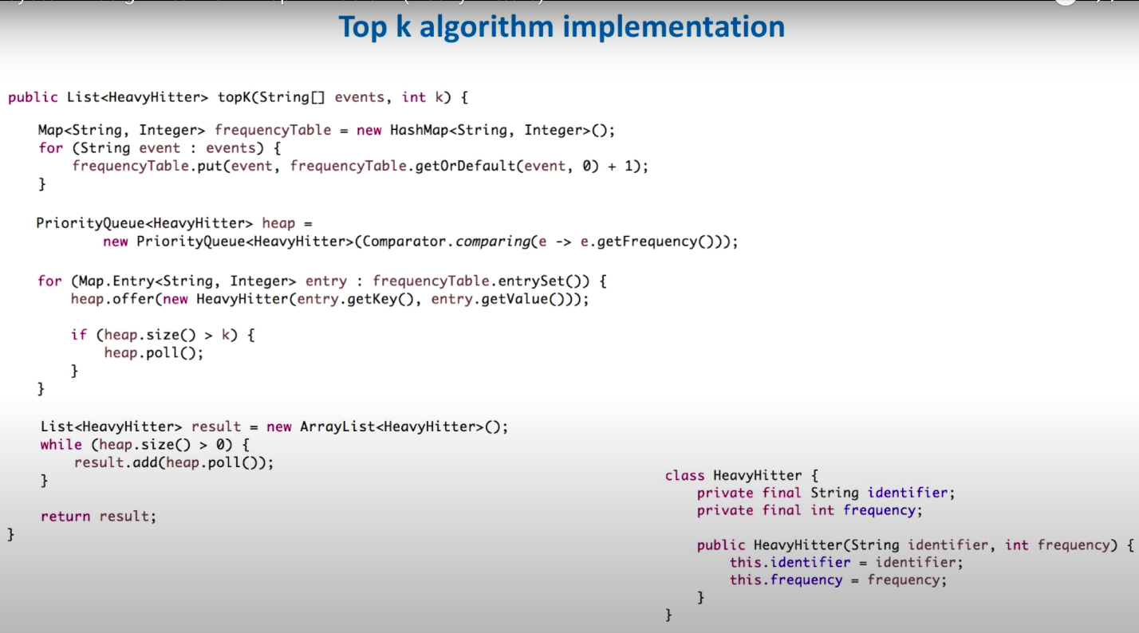

Solution 3 :HashTable/HashMap Multiple Host : We can process event in Parallel. In this solution we are storing the hashTable on each server and divide the load into multiple processor host. So load will be distributed But Still not a good solution as on each server we are storing the hashTable and if size is too big it will create the issue and also the aggregator log will also take time in computing the result. So its also not a good solution.

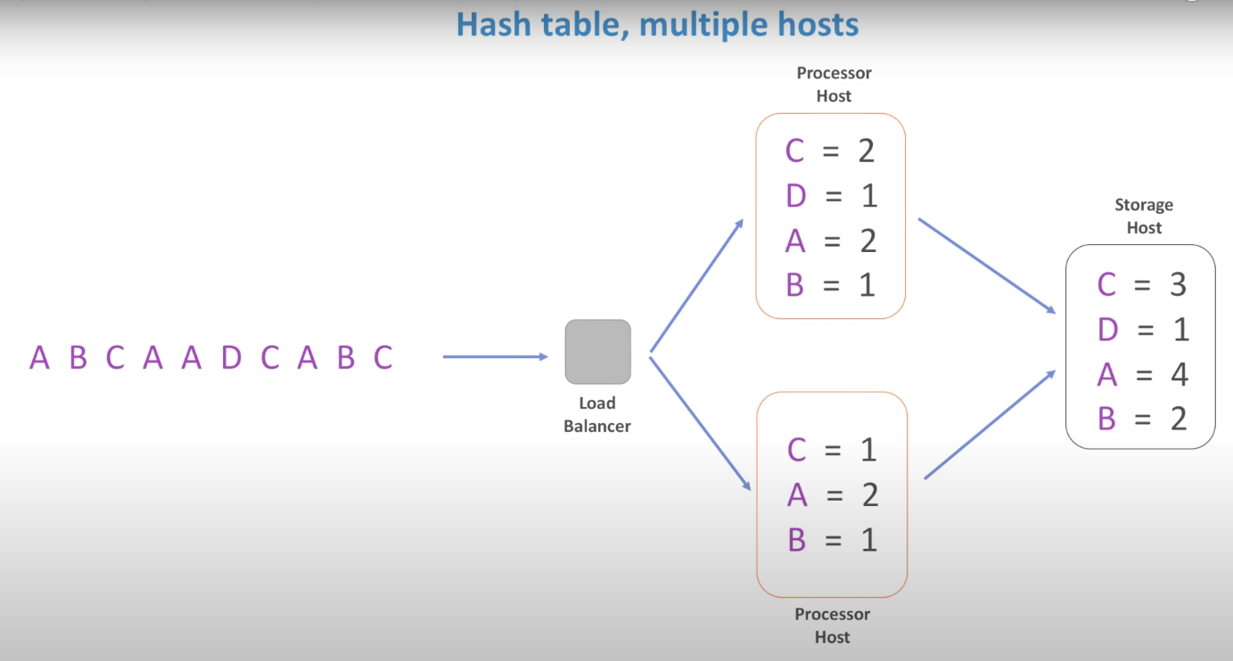

Solution 4 :HashTable/HashMap Multiple Host, Partioning : We can do the partitioning based on some prefix or may be based on first 3 chars. So it will distribute the load across the server So the hashtable size will also decrease. And also we can calculate the top k reasult in each host. And pass this information to Storage host thier we can merge all the k sorted result and can generate the actual K results. As the stream is infinite So This solution is good but it doesn’t give the more accurate result.

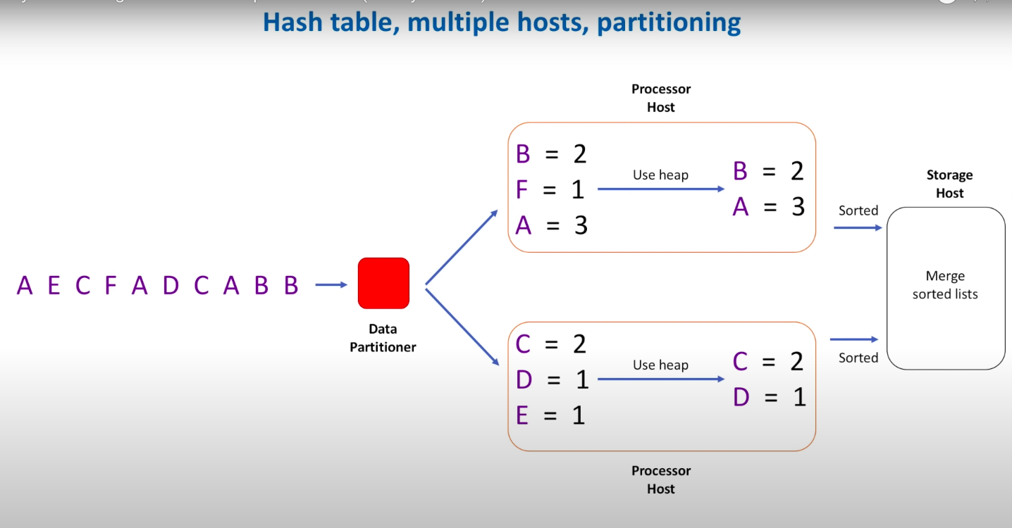

BEST Solution 6 : Max Heap + Use Count Min Sketch :

In this Solution we will not use hashTable/HashMap instead of this we will use the Count Min Sketch

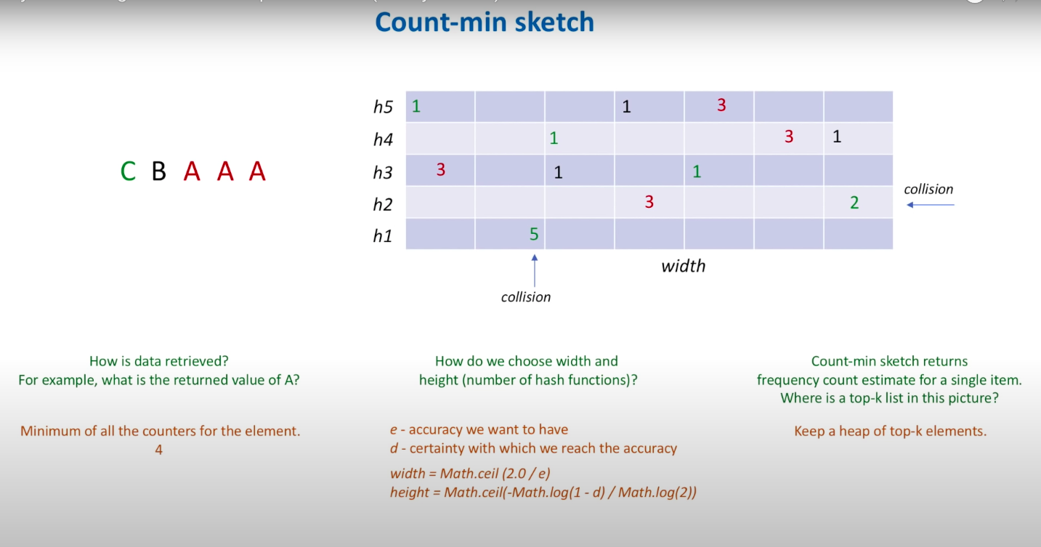

HLD :

Step 1:
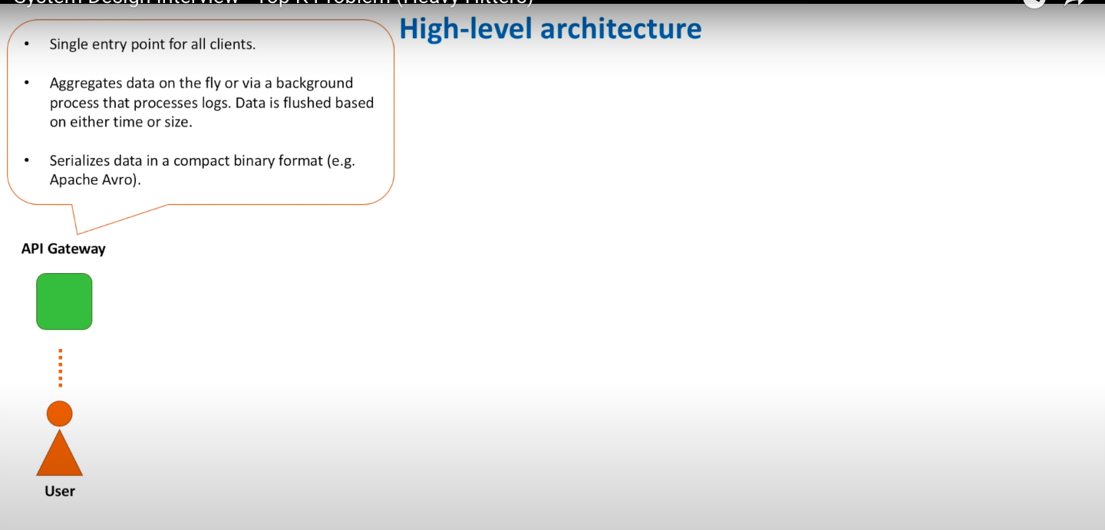
Step 2:

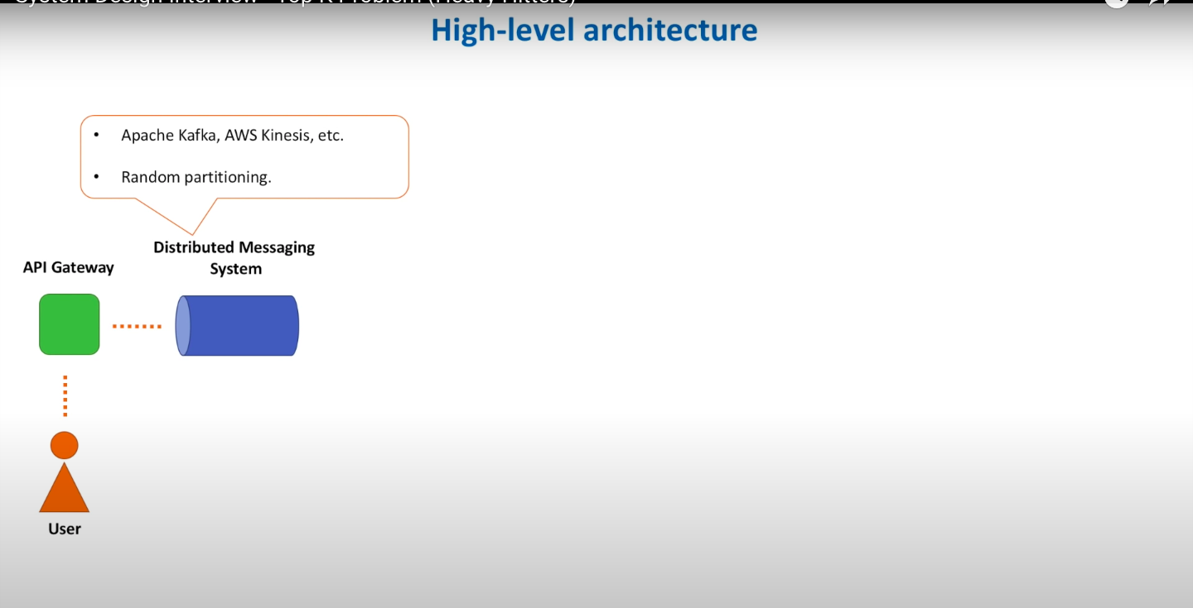

Steps 3:

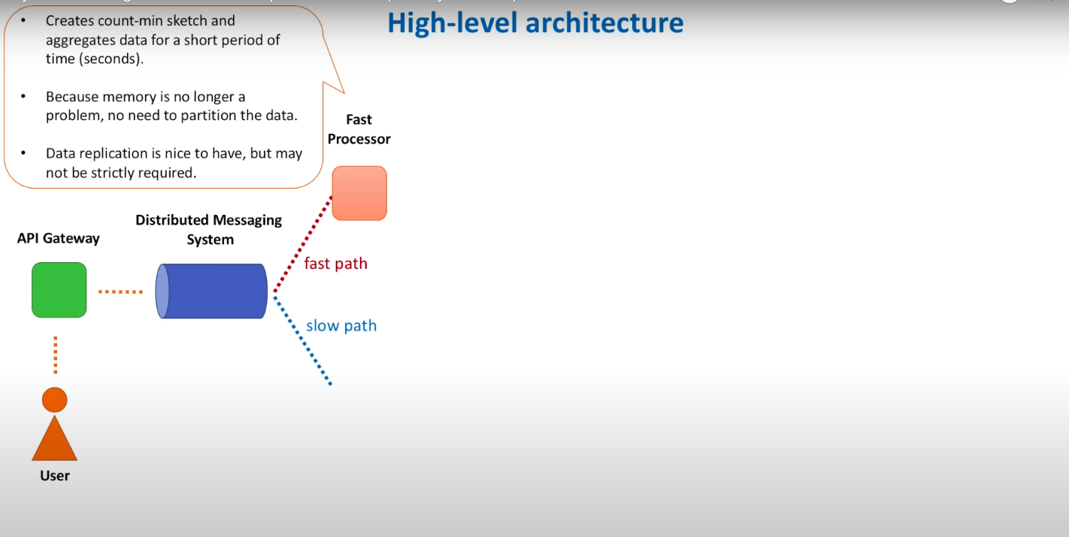

Steps 4 :

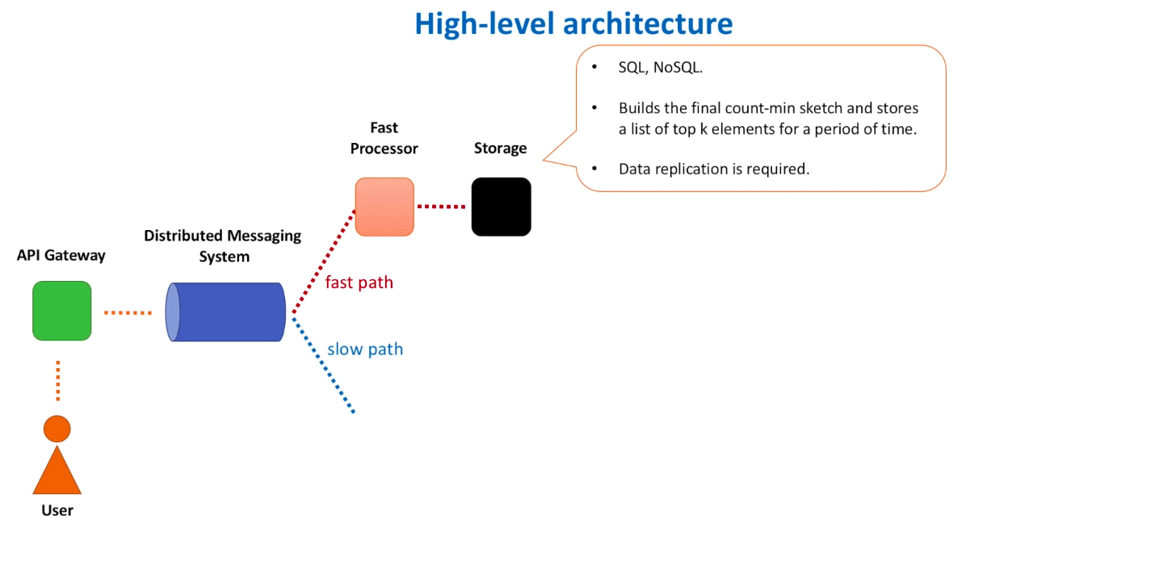
Steps 5 :

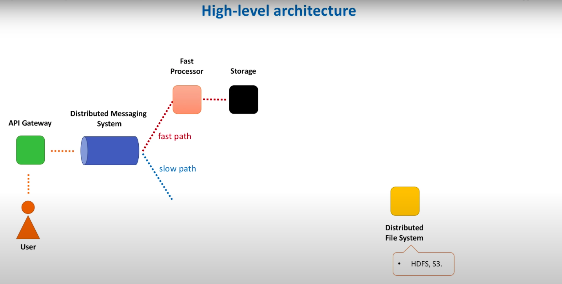
Steps 6 :

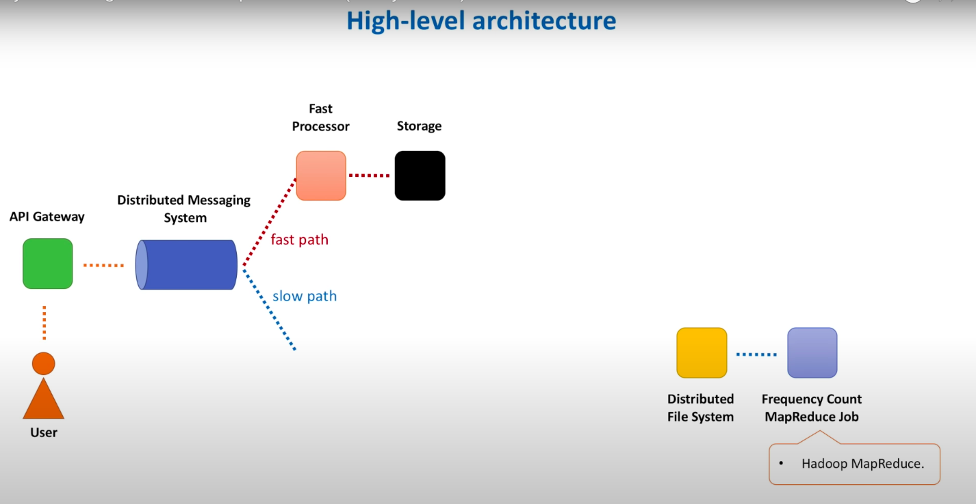
Steps 7 :

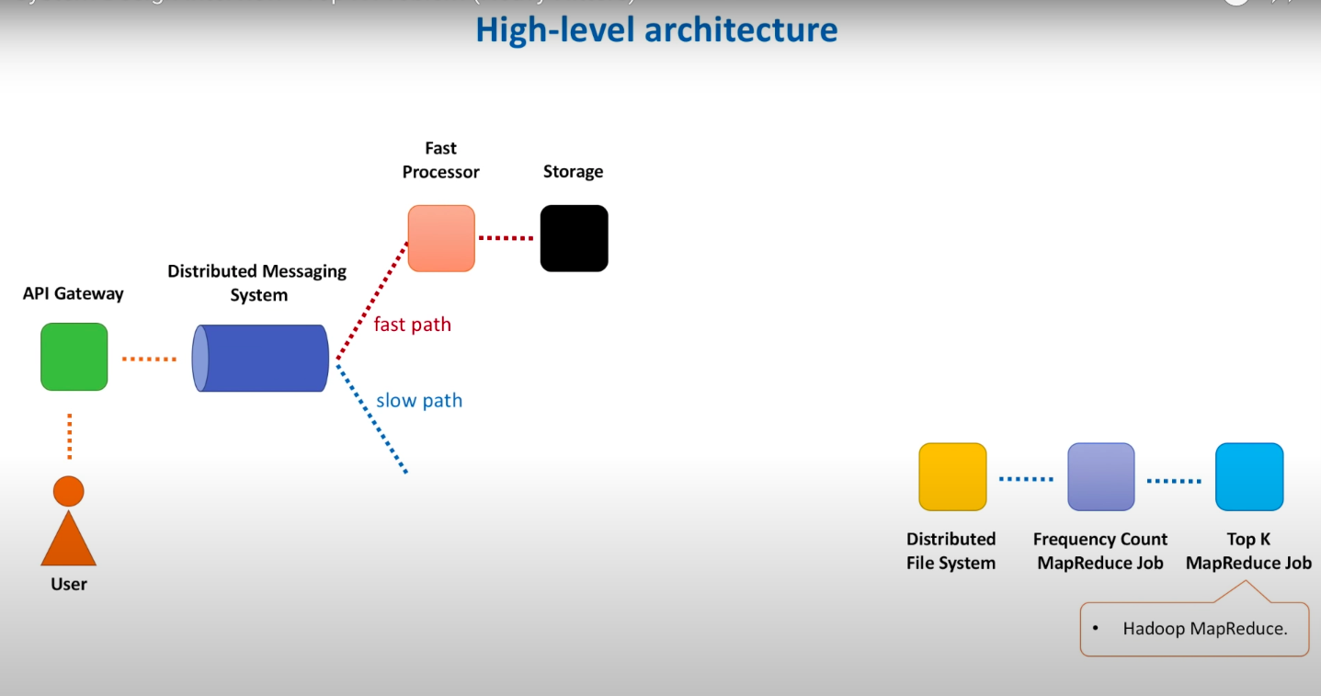

Steps 8 :
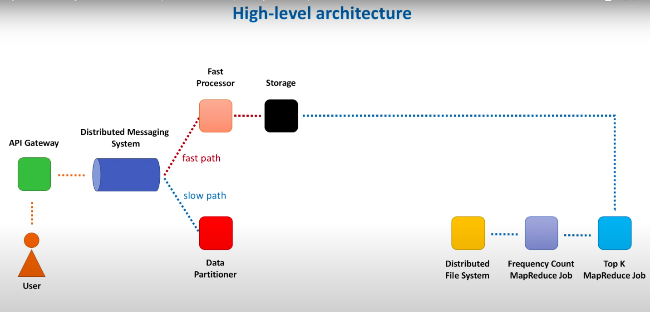

Steps 9 :
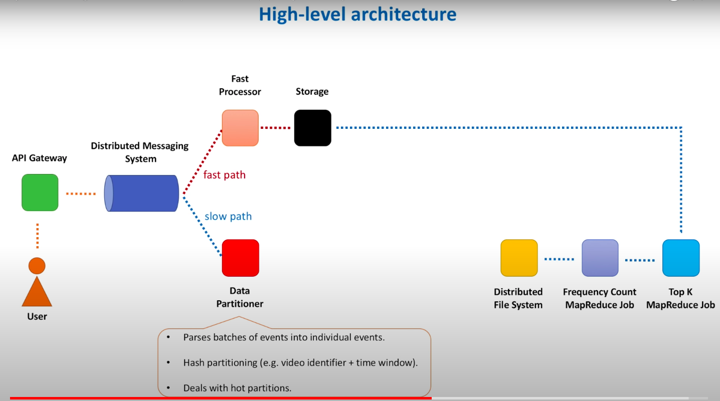
Steps 10 :
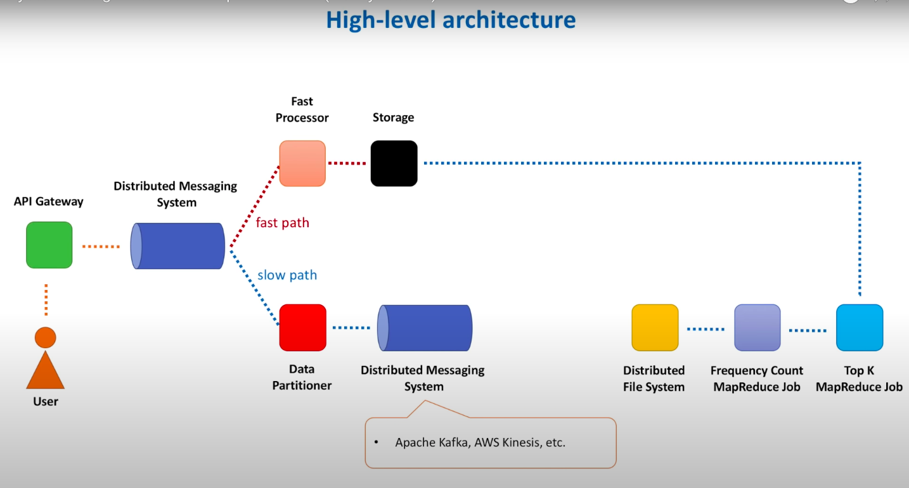
Steps 11:

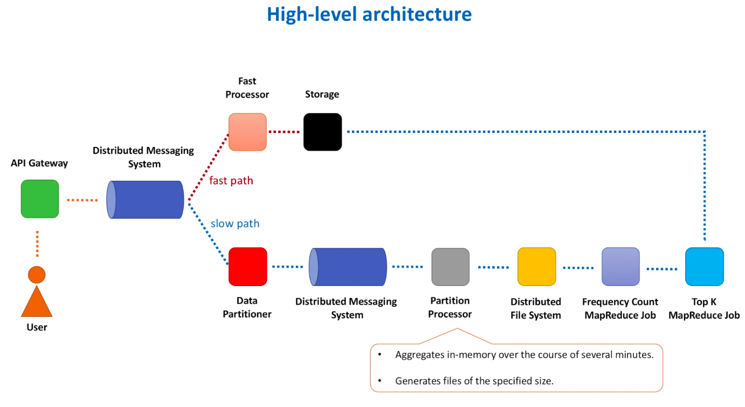

Fast Processor Approach :

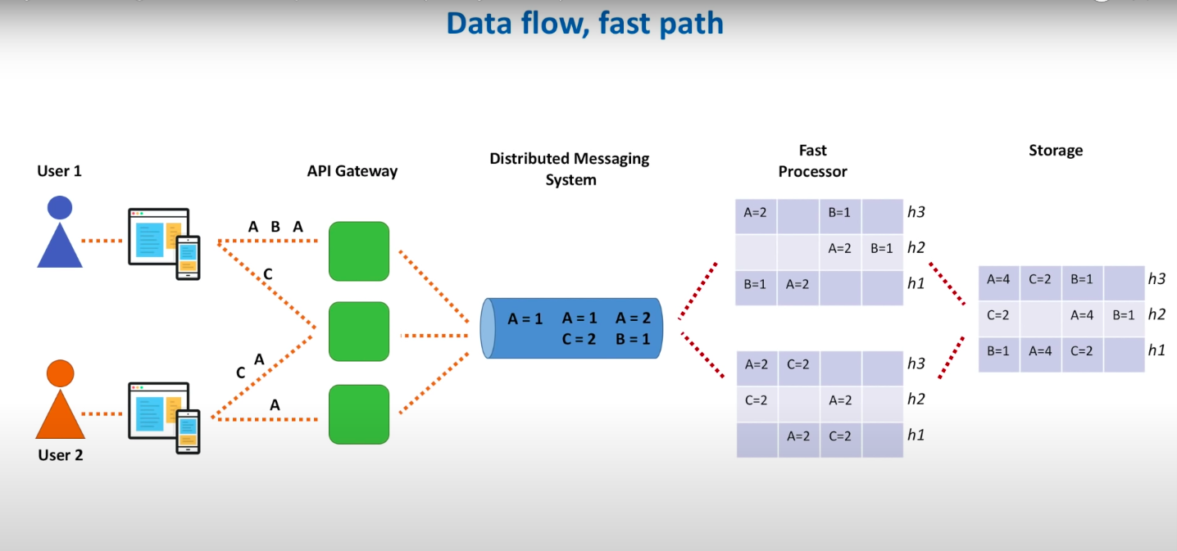

Slow Processor Approach :

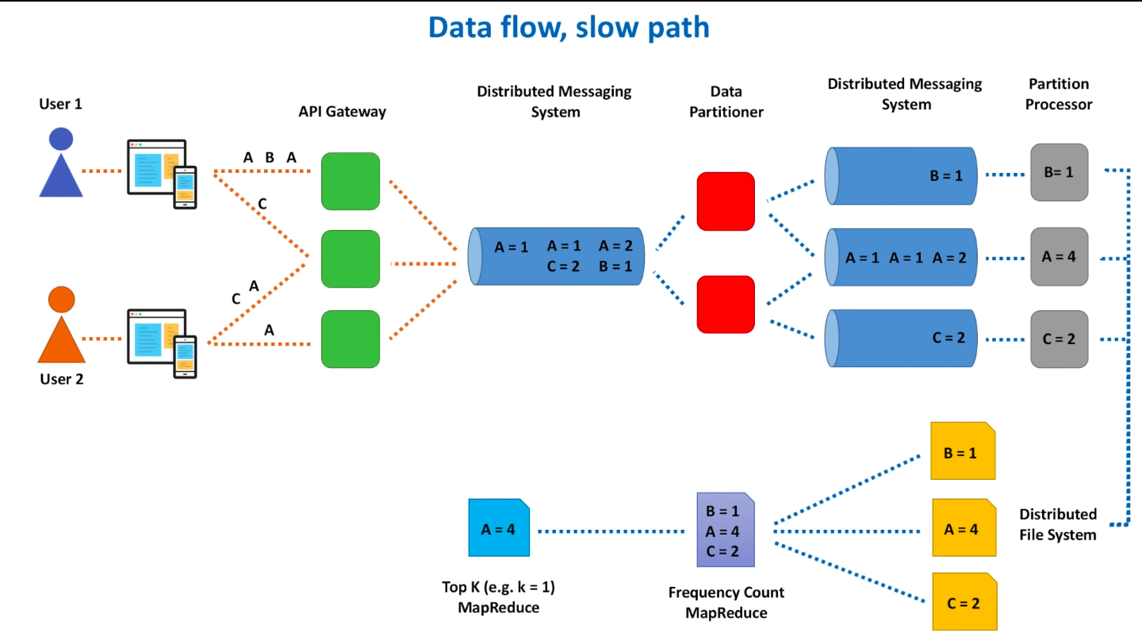
Map Reduce Jobs used in Slow Processor

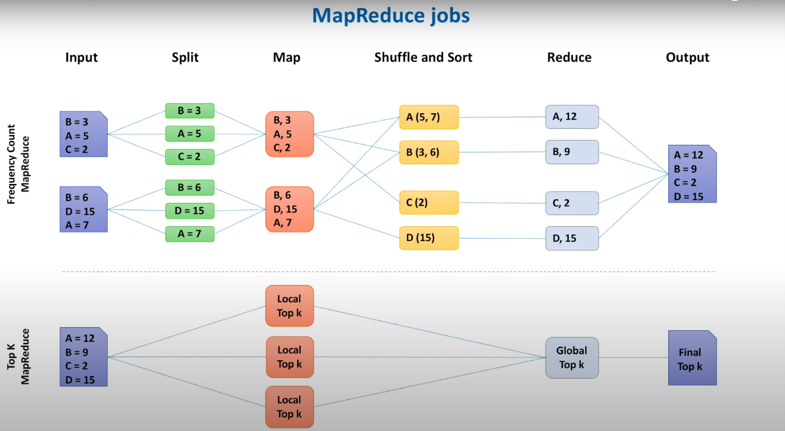

How to retrieve the Data for Top K result :

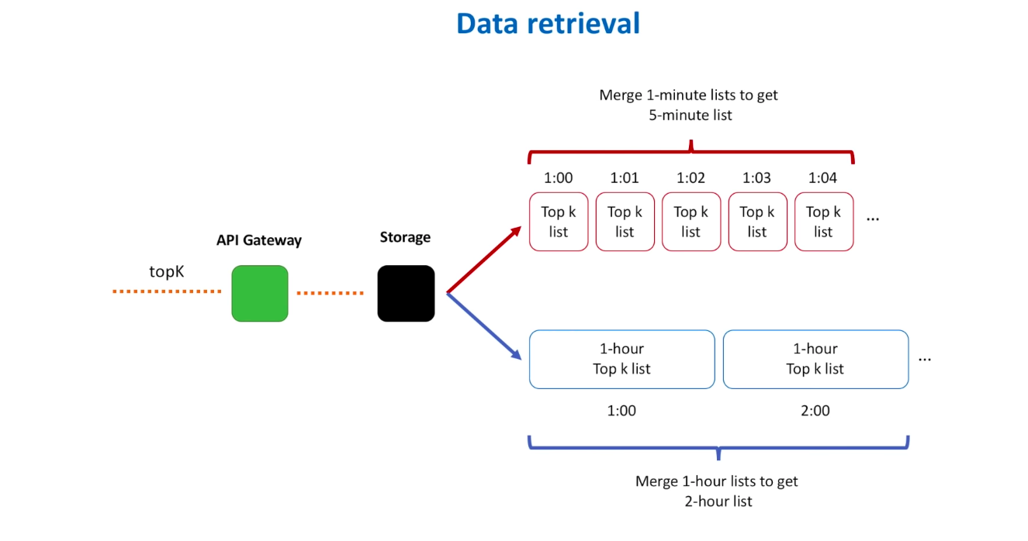

What interviews can ask :

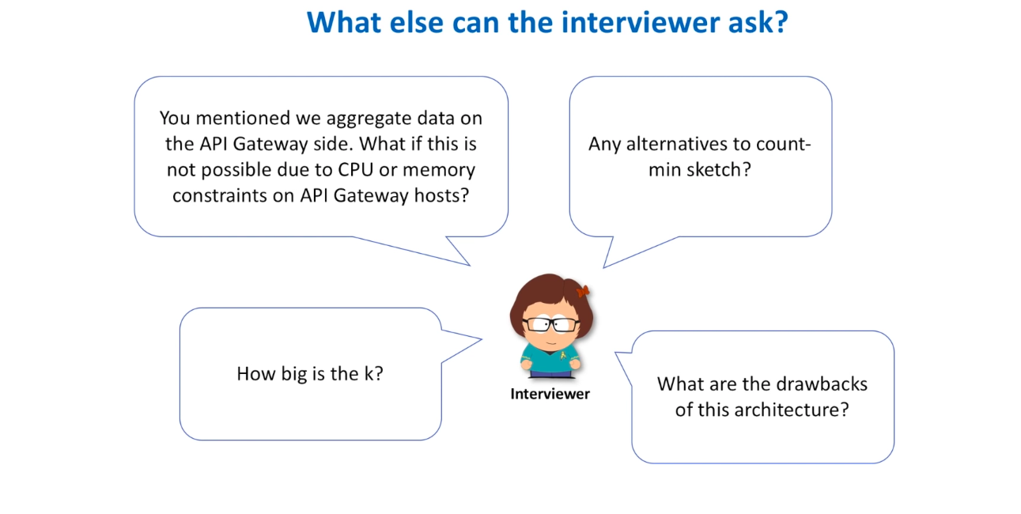

This Solution can also works below System Design as well



